|  |
| --- |
| BCIS301-AMIC700 |
| Factors that affect Technological Implementation |
| Assessment 2 |

|  |
| --- |
| Kieran Abelen, Allen Zhang, Jerry Wang  10-14-2019 |

Contents

Introduction 3

Methodology 4

Intro 4

Why uses these documents? 6

Analysis Methods 7

Quantitative analysis 7

Thematic Analysis 7

Strategic Analysis 8

PEST 8

Plan 8

Interviews 9

Mehdi 9

Sarah 9

Insights 9

Data Gathering 10

Data used 10

Validation 10

Gaps: Meta-Factor 10

Data Analysis 11

Intro 11

Quantitively Analysis 12

Technology Solution to? 12

Gap Analysis 12

A Technological Solution should? 12

Summary 13

Outcome 14

Why? 15

How? 15

PEST 15

Who? 15

Where? 16

GAp Selection 17

Tool 18

Evaluation Tool 19

Conclusion 21

References 23

# Introduction

The task of this time is to analyse the basic situation of Ara's IT department and find out the problems of Ara's IT department based on the analysed data. Not only that, we need to build a tool for these issues to provide a solution for Ara's IT department. Our goal is to provide solutions by analysing basic information.  
This will allow Ara's IT department to develop better. At the end of the project, we will create a tool to show the problems in the IT department and give a framework for finding the correct solutions.  
Ara can choose the solution that she wants according to her own situation. In addition, we have a report to introduce the development process and instructions for our tool.  
In this report, we will introduce the function, usage and explanation of the tool. The structure of this report is very clear. The first is an introduction, which introduces the goals and reports of our project.  
Then we introduced the method used in the process of launching the tool. Then, we explained in detail in the report the data content of our analysis. Immediately in the main paragraph, we describe and discuss the data analysed and explain the meaning of the processes and tools we have produced. After that, we assessed our results. Finally, we gave a summary and tested our results.

# Methodology

* What are your sources of data?
* How did you find them? Where from?
* Why did you select these sources?
* What was your approach to the analysis of data?
* Any other important issue related to the methodology you would like to present.
* Please follow the above structure (in paragraphs). Do not use brief bullet-points.

## Intro

In this project, we used six pieces of information to use. They are Community Computing, Ethics, Interview, Ops Manager, SE Tutor and Tech Labs. These six documents are like interviews or basic information. The interviewees and the basic information are from the IT department of Ara. These documents provide a detailed description of the specifics, goals, and strengths and weaknesses of the IT department. Next, I will give a detailed introduction to the general content of each document：

1. Community Computing

This document is a description of the manager of Community Computing. Introduced specific functions. Not only that, but also introduced some of the software used by Ara. I also interviewed the department manager and asked some basic questions.

1. Ethics

This document describes the positioning of the ethics tutor and his functions. Not only that, but also describes the steps students take to conduct ethics counselling. Finally, an interview was conducted, and some information was obtained.

1. Interview

This document describes the basics of Cisco Academy. Describes the situation, needs, and goals of Cisco Academy. Then, I also introduced some software installations that the network college needs. Discussed the advantages and disadvantages of the software. Finally, an interview with the network college staff was conducted.

1. SE Tutor

This document describes the teacher functions of software engineering. Introduced the specific situation of software engineering, the software needed. Not only that, but the processes and steps required for different software development directions. Finally, an interview was conducted with employees of software engineering.

1. Tech Labs

This document describes the software that you need to use when you are working on a lab. Finally, an interview was conducted.

1. Ops Manager

This document describes some of the features of Ara's IT department. Not only that, but also the specific processes and steps for the implementation of these features. Finally, some questions and answers about the interview were included.

## Why uses these documents?

We chose these six documents to help us analyse the situation of Ara's IT department. These documents contain a lot of specific information. We analyse this information to find potential problems. Then we pass these questions, and in the actual situation combined with reality, we have come up with some solutions.

After we selected the data source, we read all the literature in its entirety. Not only that, we use strategic analysis，quantitative analysis and thematic analysis. We selected all the sentences related to the IT project and then abbreviated them. Then we find the keywords for each sentence. Then we analysed all the keywords, deleted many of the same results, and used the keywords to analyse the corresponding professional words. Then we are categorizing the meaning of these words. Finally, the corresponding problems are summarized. We screened these issues again and combined similar or identical issues. Remove unimportant questions and a small number of problems. So, we can find the key important issues and give a response. Through these few steps, we finally made a checklist. Ara can use this list to find the problem of interest, and we provide one or more solutions to a problem. Ara can choose the solution according to its own situation.

## Analysis Methods

As for our analysis methods, I need to explain the definition of our methods.

### Quantitative analysis

Quantitative analysis is a method of analysing the quantitative, quantitative, and quantitative changes in social phenomena. In enterprise management, the quantitative analysis method is based on the enterprise financial statements as the main data source and processed according to a certain mathematical method to obtain the enterprise credit results. Quantitative analysis is an analysis conducted by an investment analyst using a mathematical module to quantify a company's data. It analyses the company's operations and makes an investment judgment. The main objects of quantitative analysis are financial statements, such as the balance sheet, profit and loss statement, and retained income statement. Its function is to reveal and describe the interaction and development trend of social phenomena. (KENTON, 2019)

### Thematic Analysis

Thematic Analysis is a kind of information analysis method that uses systematic steps to observe the context, culture or interaction relationship. It is also an analytical method that sees and understands the feelings and makes the truth appear.

"Theme" represents the elements that often appear in text, including the meaning of claims, idioms, or contextual contexts, and "thematic analysis" is the process of recreating these themes. From the text of the interview, the recurrence and commonality are the common theme we are looking for, so the whole analysis process follows the "whole-part-the whole" back and forth between the text and the interpretation. (Caulfield, 2019)

Gap Analysis

“Conducting a gap analysis can help you improve your business efficiency, your product, and your profitability by allowing you to pinpoint “gaps” present in your company. Once it’s complete, you’ll be able to better focus your resources and energy on those identified areas in order to improve them.” (Leconte, n.d.)

The entire tool will simulate a gap analysis on each piece of technology and try to rate how successful the solution or technology will solve that gap.

### Strategic Analysis

Strategic analysis is a process involving the business environment in which the research organization operates. Strategic analysis is critical to developing an organization's strategic plan for smooth decision making and smooth work. With strategic planning, the goals set by the organization can be achieved.

In order to continually improve, organizations must conduct strategic analysis on a regular basis to help them determine what needs improvement and what is done. For an organization to function effectively, it is important to consider how to implement positive change.

### PEST

A PEST analysis is a strategic business tool used by organizations to discover, evaluate, organize, and track macro-economic factors which can impact on their business now and in the future. The framework examines opportunities and threats due to Political, Economic, Social, and Technological forces. Outputs from the analysis inform strategic planning processes and contribute to market research. (GroupMap, n.d.)

This will be adapted to strategic analysis (four elements). Each PEST heading will be scaled down to fit inside and organization.

1. Political -> Management
2. Economic -> IT Department
3. Social -> Users
4. Technological -> Technology System

### Plan

1. Thematic Analysis
2. Gap Analysis
3. PEST
4. Tool

# Interviews

## Mehdi

I mostly talked to Mehdi sitting down the back most of the time, during my talks I identified key areas I needed to work on.

* The tool should not offer solutions but be used to recommend them.
* The tool should only be formulated not only thematic analysis but also strategic analysis.
* The tool should be a combination of agreed upon frameworks.

## Sarah

I interviewed Sarah briefly and she gave me insight into finding information

* The information needed is on Moodle
* We should be using us in class notes over outside information

## Insights

We need concrete information on how to do any given tasks without a clear direction we get lost in long winded discussions. Using us in class notes and finding frameworks that can fit this information seems to be our best approach.  
It worked for the first assignment and we have now applied it for the second assignment.

# Data Gathering

## Data used

We agreed that we would use every excerpt since the analysis might not be apparent until the gaps are identified. The excerpts need context so long enough to understand was is going on, for example all the bullet points under a heading.

## Validation

All the excerpts have been validated by asking if this is a true gap. The gap does not have to be a negative or problem aspect of an excerpt but could be a positive aspect.  
We where trying to identify what is important about each technology implementation.  
If there was something negative or positive what was the culprit or underling theme.

## Gaps: Meta-Factor

All gaps need to simple and explain as issue from a current solutions or lack of and the final solution. Let’s say the current system is Microsoft and everyone is used to this familiar style, and obvious gap is trying to get used to a new system. The gap is familiarity with best solution being the most familiar.

# Data Analysis

## Intro

The Gap analysis is designed like risk analysis for the planning stages of any project. There will be a list of objectives or goals in any projects and you need to find the gap between the existing state of an objective to its planned outcome or goal.

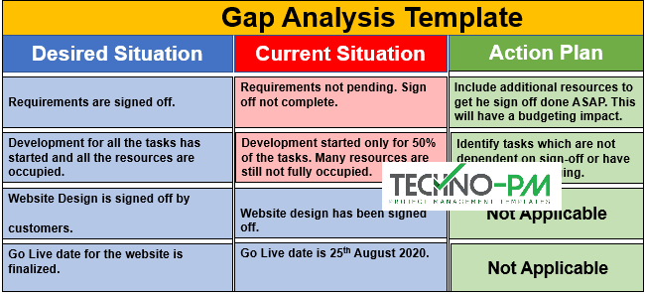

This sets the perfect scene for our analysis since all gaps are not issues or problems with the report, but issues or problems to achieve the objective or goal.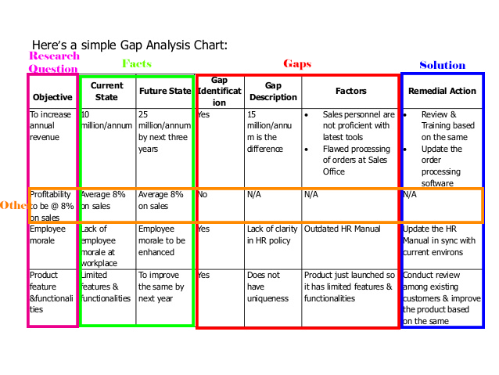

## Quantitively Analysis

During the initial data gathering the question is

### Technology Solution to?

* Help an IT profession
* Help a software engineering tutor
* Enable the team to work together
* Help the ethics process for projects
* Would attract more networking students
* Help an IT profession
* Set up a WAN
* Preform digital collaborations

These helped identify the correct Gaps in the data; Automation, Communication, Compatibility, Familiarity, Financial, Security and Training.

## Gap Analysis

A new set of questions needs to ask around each gap. This will help set a scene for the Gap analysis since it will give us context around a beginning and final state.

### A Technological Solution should?

1. Automate an existing process that is taking too long or is too costly
2. Allows multiple communication functions removing physical barrios like location and technological ones like different calendars.
3. Be compatible with current systems without needing extra solutions.
4. Be familiar with staff so they don’t need any prior training to operate it.
5. Be within the budgeted amount of time and money.
6. Protect any information and be secure when communicate it.
7. Have adequate training built it for any of its new systems.

This is the best-case scenario, so each technological replacement should tick all these boxes.

## Summary

Each report provided by ARA has given us insight into the sorts of issue that arose in its technological implementation/proposal. With this knowledge a list of gaps can be formed along with a list of questions that should be asked to overcome these gaps.

1. Automation
2. Communication
3. Compatibility
4. Familiarity
5. Financial
6. Security
7. Training

These gaps will help inform our tool by rating how successful each technology resolves these gaps.

# Outcome

What?

The outcome will develop the Gap analysis methodology so it can be applied to any technological implementation.

The tool will objectives for each gap, Then the current state of any system before-implementation and an after-implementation state.  
Each solution will be tested against the gaps found during out quantitative analysis. The rating assigned to each gap came from the breakdown of the gaps in our Gap analysis.

The solution is a tool that can breakdown any solution even simple ones to suites.

|  |  |
| --- | --- |
| Automation | 1: The Solution has a stated specification for the issue 2: The Solution can solve the issue but is not clearly stated 3: The Solution with another system can solve the issue |
| Communication | 1: All communication types covered 2: There is Communication but not with outside solutions 3: There is no communication but can output to an outside solution |
| Compatibility | 1: Solution completely integrates 2: Solution can integrate with extra services 3: Solution needs extra solutions to integrate |
| Familiarity | 1: Solution is in the same suite or enterprise 2: Solution is part of the same family or company of products 3: Solution is designed to imitate a familiar style |
| Urgency | 1: Solutions can be implemented immediately 2: Solution will be implemented but will take time to become fully operational 3: solution will take some time to develop but then will immediately become operational |
| Security | 1: Stored and network information is secure 2: Stored information can be secured but not network information 3: Stored information cannot be secured but network information is |
| Training | 1: There is robust help and tutorials with the Solution 2: There is robust help but no tutorials 3: There are tutorials but not help menu |

The list shown are best case scenarios going down the list.  
A technological solion that achieves positions one will be provided with full marks.

1. 100% rating
2. 50% rating
3. 25% rating

This is harsh but will more clearly define each solution and it gives the user better targets or discretion when decidng a score between these ratings.

## Why?

The real question us why we should use these gaps since not every IT solution is same some solutions might not even Automate any process since it was manual to begin with like communication.

## How?

The next set of analysis will help the User of the tool decide what Gaps should be used.

### PEST

I searched far and wide for what strategic analysis (four elements) was. Based on others in the class and out notes its boils down to people, process, tool, value. Every Gap or even solution should address these four elements.

Pest perfectly fits into this, but we will use a more local version of it.

## Who?

1. Political -> Management
2. Economic -> IT Department
3. Social -> Users
4. Technological -> Technology System

Each Gap needs to fit into one of these categories so it can be addressed in the planning hierarchy.

## Where?



# GAp Selection



# Tool



Once an Objective has been set and the correct Gaps are identified from the planning hierarchy.

# Evaluation Tool

The table below shows all the group gaps and solutions for each gap.

|  |  |
| --- | --- |
| **Gaps** | **Solutions** |
| Automation | 1. Use Altius. Altius helps companies speed authorization for expenditure AFE approval times, automate workflows, and gain deeper insight into capital spend—resulting in better decision-making. 2. For attendance records, schools can use dynamic QR codes. Each course will be provided with a new time-limited QR code. Students can check in by scanning the QR code. This reduces the amount of work and reduces the probability of errors in registration. |
| Communication | 1. Use skype, skype can share screens, all work on ONE single platform 2. Use Coggle. An online collaborative mind map. People can add/change things and do not need to gather up at the same place. |
| Compatibility | 1. Task management tool (i.e. Monday Project management tool)   www.monday.com/‎   1. Microsoft OneDrive Cloud storage. Microsoft OneDrive storage has been adopted by most education institutions. |
| Familiarity | 1. Trello with Microsoft Power BI. Trello has been used as an alternative collaboration tool and it has proved to provide a more user-friendly experience in comparison to Microsoft Team and SharePoint. A suggestion is to sanction Trello as an official collaboration tool and upgrade it to the enterprise version. Trello can be easily integrated with Microsoft Power BI via Stitch to analyse the Trello data by Power BI. |
| Urgency | 1. CISCO costs a lot. Schools can recruit more students, and not only can they train teachers, so they can not only make money but also cultivate talents. And CISCO Academy should record every expense for recording and backup. 2. Ara should upgrade the backend equipment as much as possible, although this will lead to an increase in upfront costs, but the benefits will be higher. Good devices can run daemons more efficiently. Not only that, but schools can also have better… |
| Security | 1. Purchase the official version of Coggle to ensure security and usability. If the budget is tight, we can consider replacing the software. |
| Training | 1. Web Crawling technique (i.e. Apify)   https://apify.com/ |

Evaluation tool

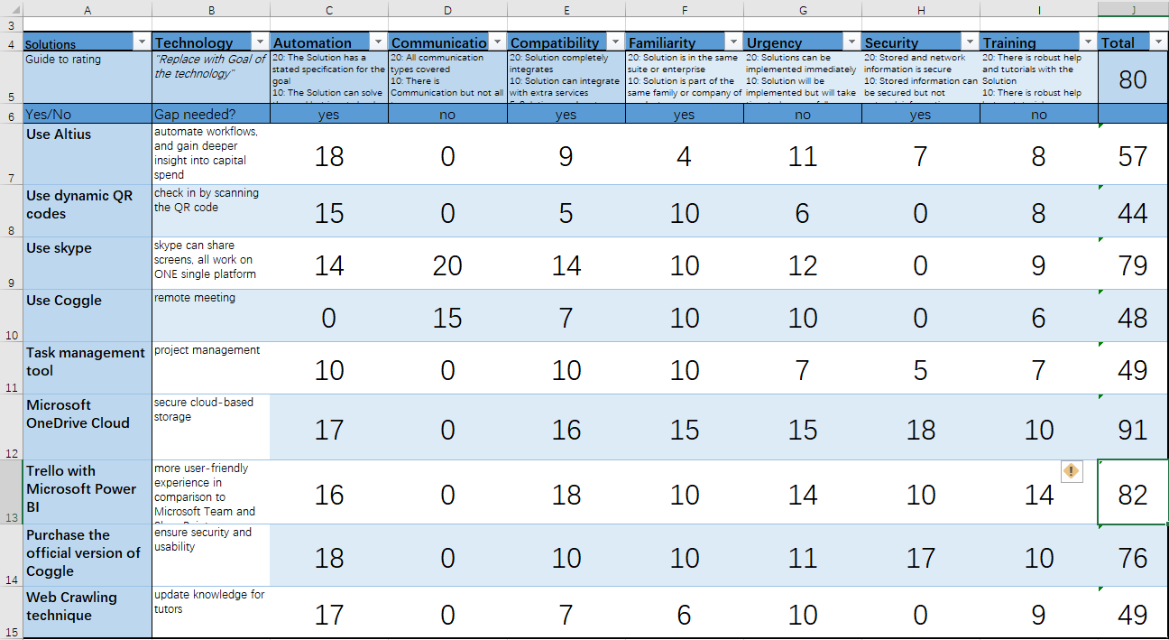

The selected technology projects from the pool of solutions for the next three years are by using evaluation tool are: Microsoft OneDrive Cloud, Skype, Trello with Microsoft Power BI.

# Conclusion

Our main goal is to provide the best solutions to improve the performance of the Department of Computing at Ara. Firstly, we completed our qualitative data of Ara’s IT Department based on the given transcripts and interview with other two teams through strategic analysis and grouped them up to seven main gaps, which are Communications, Compatibility, Familiarity, Urgency, Security, Training. Then we figured out the possible solutions based on the thoughts of ourselves, which will possibly improve the performance of Digital Innovation. In the main body, we explained the reasons how these solutions solve problems based on the four-element outcome. Secondly, we conducted evaluation by using the tool we built. Finally, three best solutions are selected from the pool of 9 technologies.

The Final Facts, Gaps, Solutions form are demonstrated below.

Goal

Solutions for performance improvement of Ara's IT department

Issues

Lack of software functionality

Manually operations

Limited storage

Communications

|  |
| --- |
|  |
|  |

automation Communication Compatibility Familiarity Security Training

solutions

official version of Coggle

Coggle

OneDrive Cloud

Web Crawling technique

Trello with Microsoft Power BI

Task management tool

skype

Dynamic QR code

Altius

Evaluation tool

Communication Compatibility Familiarity

Proposed

Skype

Trello with Microsoft Power BI

OneDrive Cloud

solutions

# References

Caulfield, J. (2019, September 6). *How to Do Thematic Analysis | A Step-by-Step Guide & Examples*. Retrieved from www.scribbr.com: https://www.scribbr.com/methodology/thematic-analysis/

GroupMap. (n.d.). *PEST Analysis Template - Political, Environmental, Social, Technological*. Retrieved from www.groupmap.com: https://www.groupmap.com/map-templates/pest-analysis/

KENTON, W. (2019, Apr 18). *Quantitative Analysis (QA) Definition*. Retrieved from www.investopedia.com: https://www.investopedia.com/terms/q/quantitativeanalysis.asp

Leconte, P. (n.d.). *Conducting A Gap Analysis: A Four-Step Template*. Retrieved from https://www.clearpointstrategy.com/: https://www.clearpointstrategy.com/gap-analysis-template/